System Management System – User Manual instruction for very first use

1. Set up database
   1. Open file StudentManagementSystem.sql



* 1. Execute these commands in SSMS

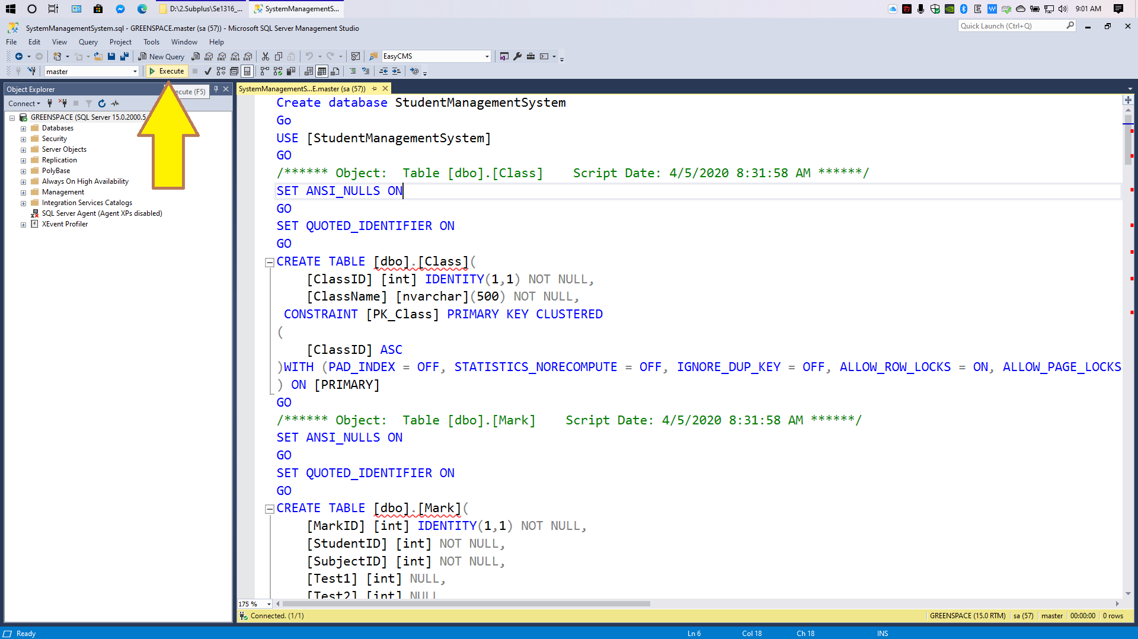

1. Open project solution
   1. Open program

Users choose the: Se1316_Group5_StudentManagement.sln file and click Open in option

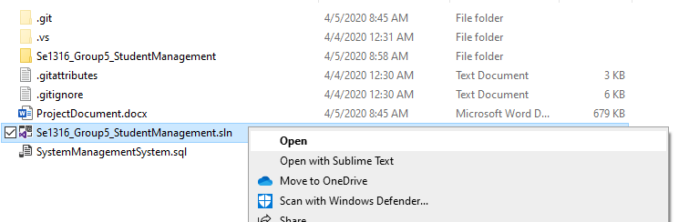

* 1. Click Start to run program

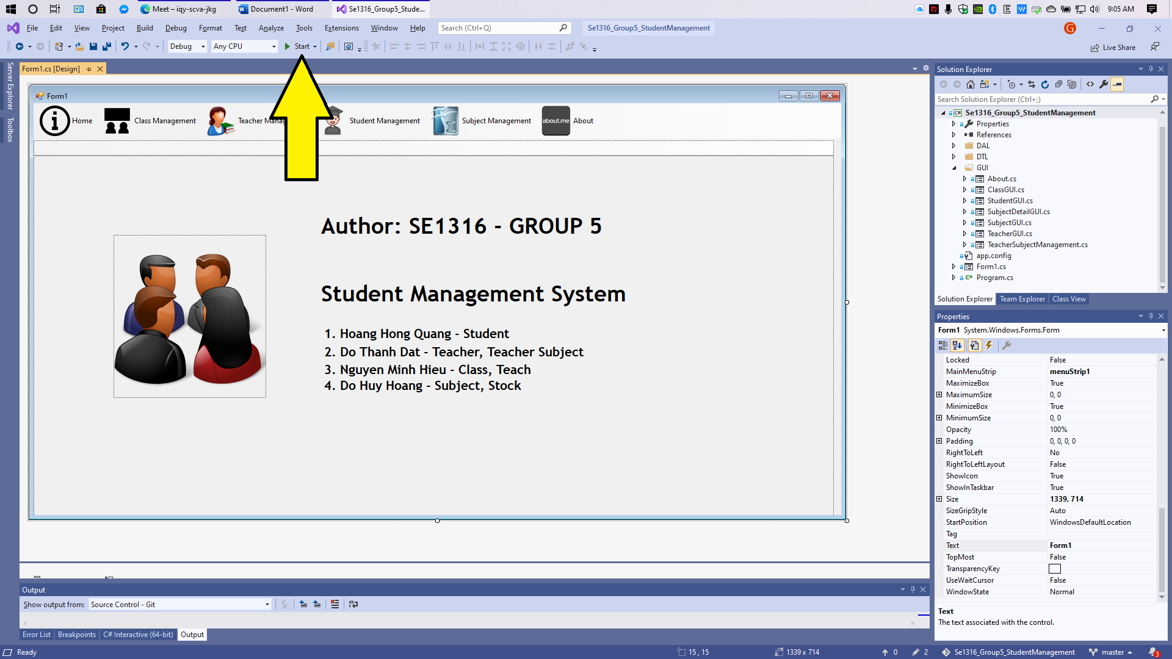

1. Open a single Usecase
   1. Open Class Management

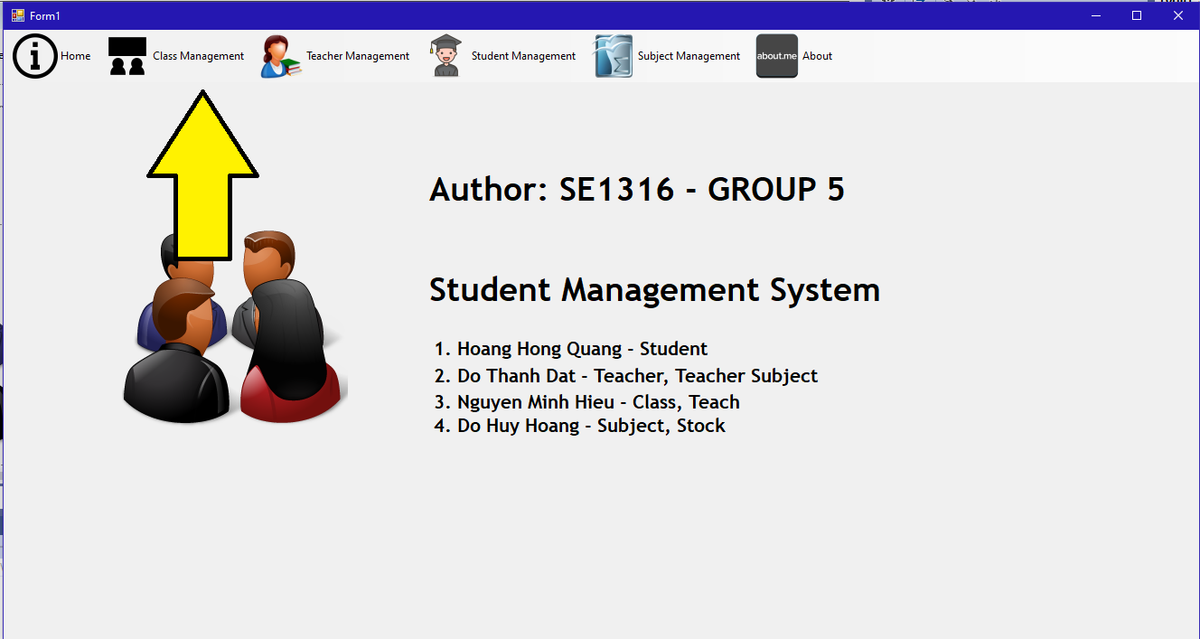

* 1. Open Teacher Management

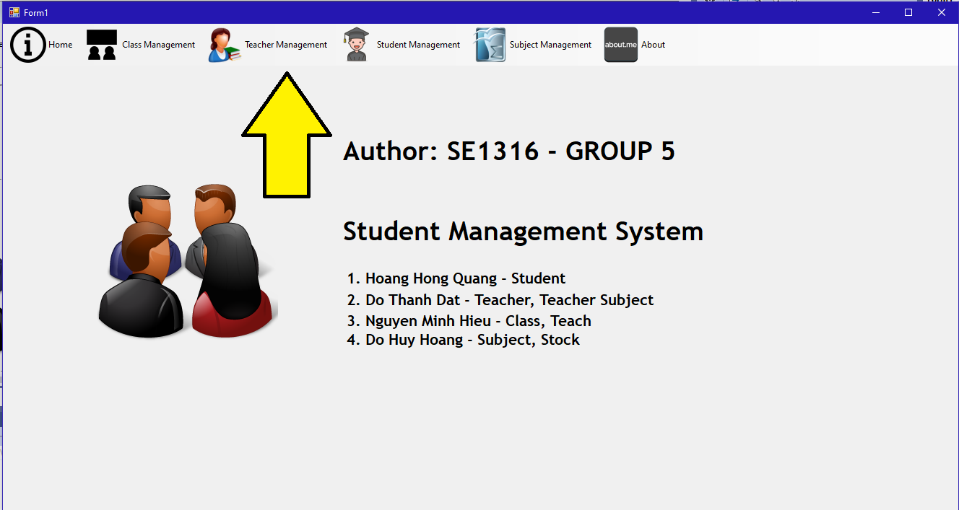

* 1. Open Student Management
     1. Open

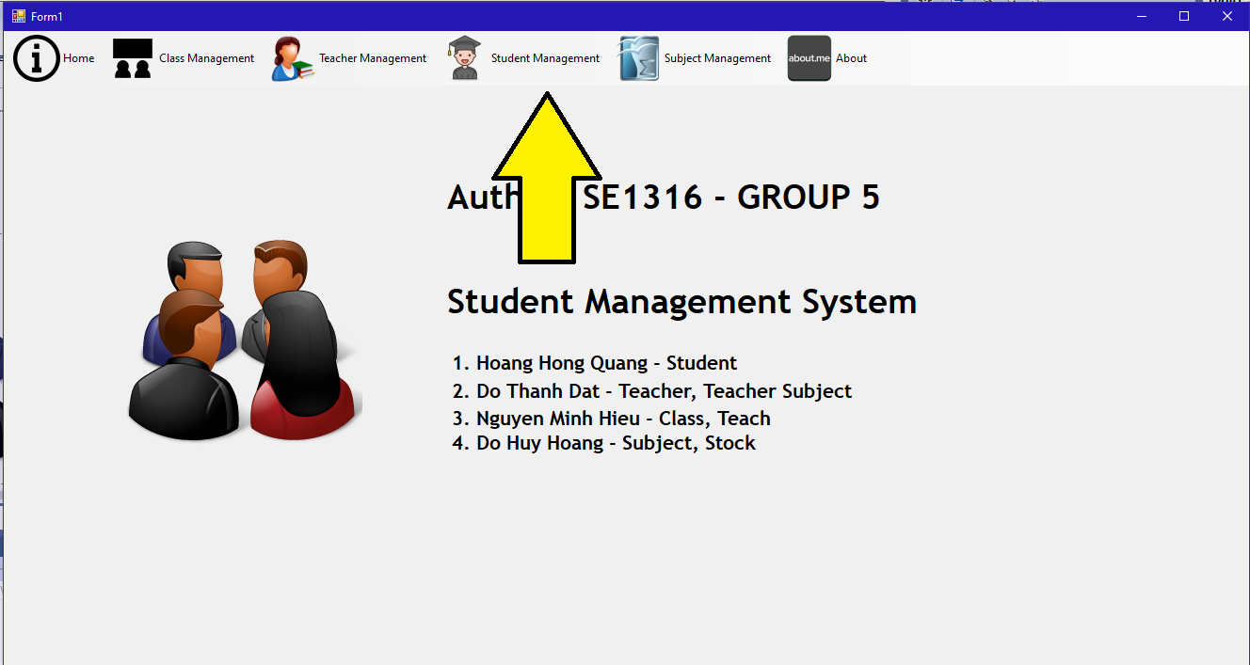

* + 1. Click Oke to confirm

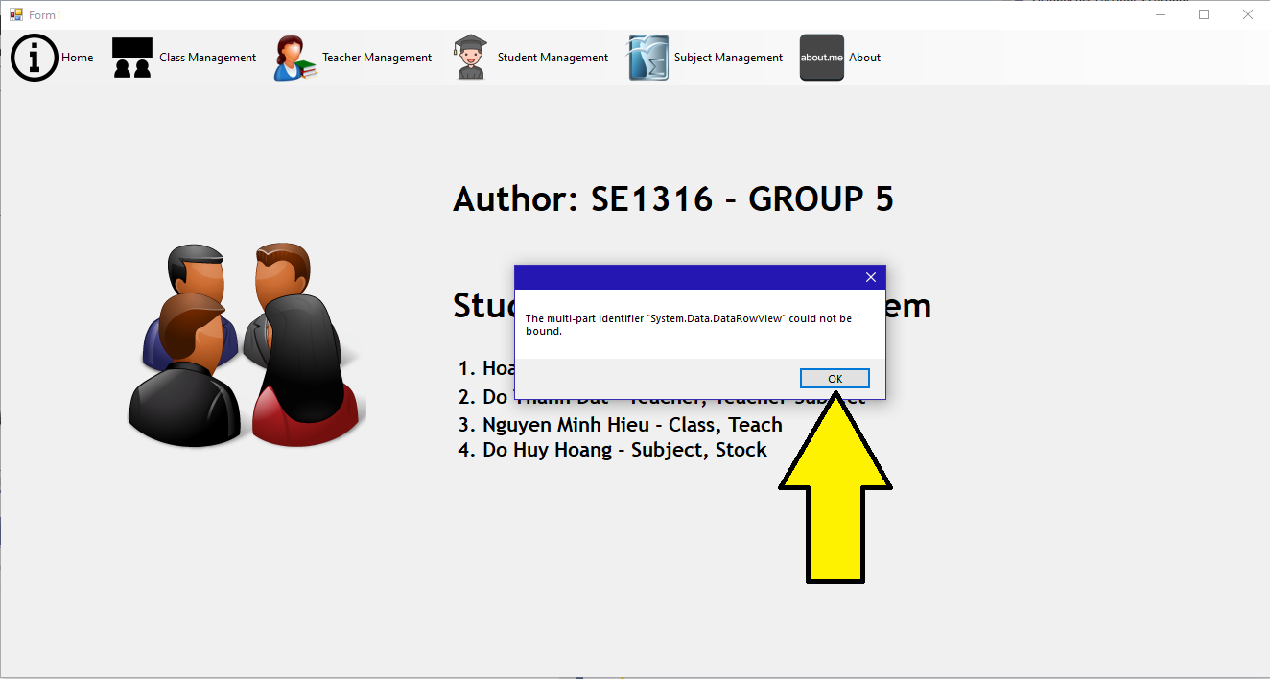

* 1. Open Subject Management

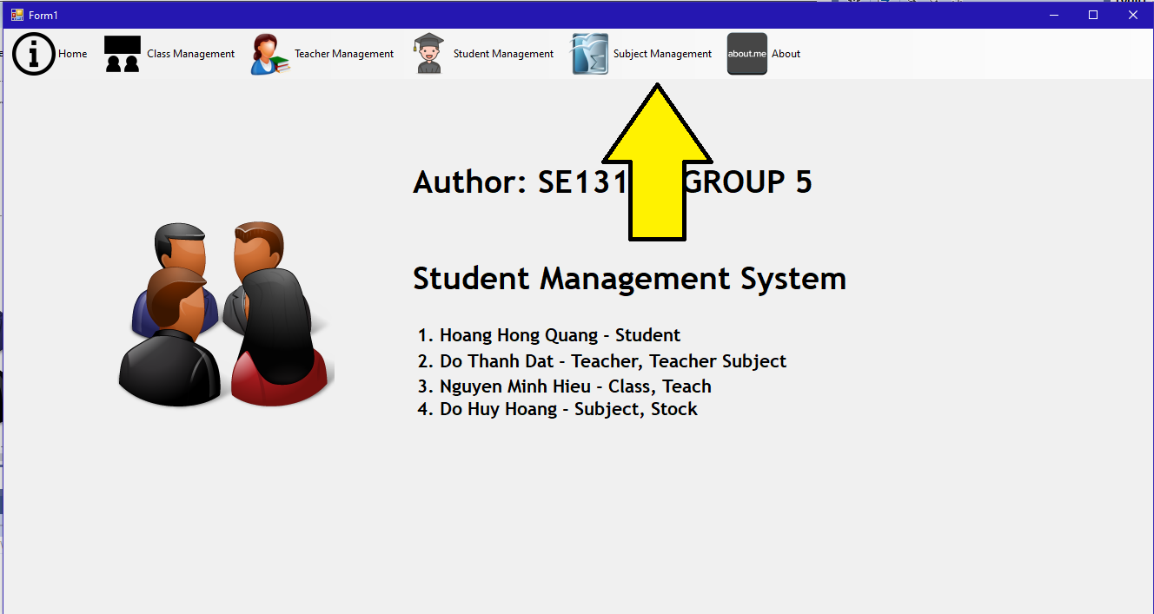

* 1. Open About

